Lisa Muller, Principal Consultant, SBR Consulting
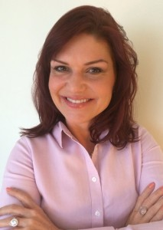Experience:
Lisa has over 20 years of Consultative Sales and Commercial experience in both North America, UK and EMEA. After achieving multiple sole contributor Top Performer awards in the US, she then moved in to Sales Management in the UK where she successfully took on large-scale complex Sales and Commercial projects in excess of £28m and £14m leading to increased sales, revenue, profitability and retention.
After many years working with large corporate organisations in the UK and US, she went on to lead the commercial and sales direction for software (SaaS, On-Premise and Hosted) solutions as well as managed and professional services for small to mid-Sized organisations looking to expand in the UK and EMEA.
Her Passion is Sales Excellence via the effective development of people, process and strategy. She genuinely loves seeing people and organisations become successful and thoroughly enjoys working with clients to help them achieve exceed their goals and objectives.
She has extensive experience with:
– Online and Hardcopy Information and Publishing Organisations
– Software and Managed/Professional Services Organisations
– Legal, Tax, News/Business, GRC Products and Industries
– Strategic Commercial Change Strategies: Product/Commercial Migration, Subscription
– Account Management (Up-Sell / Cross-Sell) Modelling
– Retention and Growth Sales Models
– Commercial / Sales / Customer Experience Transformation programs
– Sales Operations
– Sales Tools Development and Implementation
– Sales Process Mapping
– Data Analytics and Transactional Data Analysis for Sales, Operational and Customer Experience Improvement
Lisa will be presenting an award at the ‘Women In Sales’ Awards on 5th December at the Savoy Hotel.Sales is the lifeblood of every company. However, it is still very heavily male-dominated. The Women in Sales Awards has been created to bring a greater awareness of the need for gender diversity in sales and in executive leadership teams, as well as help grow the pipeline of sales talent. The awards are an opportunity to celebrate the achievements of women in sales roles. Click the image below to find out more about the event.
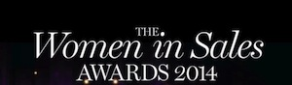
Qualifications:
BSBA with a concentration in Marketing from Valparaiso University as well as International Studies experience.
Interests:
When she isn’t helping her clients, she enjoys spending time with her two boys, family and friends and loves writing, doing volunteer work, coaching football/soccer and teaching (especially children with special needs).
Click here to view Lisa’s LinkedIn Profile

