THREAT / RISK SECURITY & SAFETY WEEKLY BULLETIN (brief assessment)
June 29 to July 06
Brief Update: No 10-2/2026 Date: July 07, 2026
In references to:
- SEA GUARDIAN Monthly Threat & Risk Assessment No 10-1/2026 29th May to 29th June, 2026

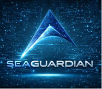  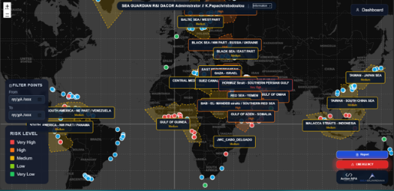 | INSIDE
 | - According to Sea Guardian observations, evolution in diplomacy, military presence, and sanctions are causing rapid changes in the environment at vital choke points, while an upsurge in piracy, criminal activity, and cyber-attacks is posing greater disruption risks to energy and cargo flows, calling for flexible routing and enhanced physical-cybersecurity on all involved routes.
 | News finds this week (top three most important)
- Control of Hormuz navigation by Iran: The need for tankers to follow their routes due to threats, makes this navigation zone more dangerous in terms of legal and incident threats.
- Persistent presence of Chinese coast guard east of Taiwan: The constant presence of the Chines Coast Guard east of Taiwan turn the area to a more vulnerable in grey-zone operations.
- Militarization of Baltic-Arctic theater: The establishment of the new NATO command center and the Arctic cutter program make this area more fragile due to great power competition.
 | Corporate conclusions
 | - In sum, the current trends reveal that chokepoints and strategically important maritime routes are becoming more affected by coercive measures taken by coastal states in the form of gray-zone operations and militarization.
 | The observer
 | - Next week, conditions will be fragile and fluid. Political actions and sanctions can swiftly bring changes in chokepoints regulations, while the ongoing conflicts increase the risk of indirect disruptions. Trade routes become unstable due to tight security in Hormuz, Suez, and WIO (Western Indian Ocean) coupled with piracy, while organized crime operates in poorly governed regions.
MARITIME SECURITY & NAVIGATIONAL SAFETY INCIDENTS
SOURCE / I.D | DATE | TYPE | SECURITY/SAFETY AREA
MSCIO ALERT / 69/26 | July 02, 2026 | PIRACY | Gulf of Aden
UKMTO WARNING / 077-26 - ILLEGAL BOARDING | July 01, 2026 | PIRACY | Gulf of Aden
UKMTO WARNING / 078-26 - SUSPICIOUS ACTIVITY | July 01, 2026 | PIRACY | Gulf of Aden (IRCC)
UKMTO WARNING 079-26 / MSCIO ALERT 70/26 | July 05, 2026 | PIRACY / FIRING | Red Sea / Yemen
Week’s new findings
ARCTIC CYCLE / BALTIC SEA
{ Chart 1 }  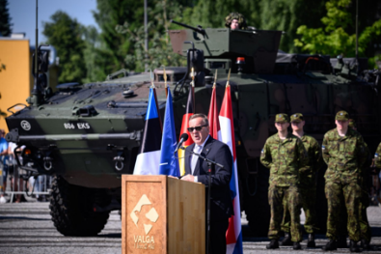  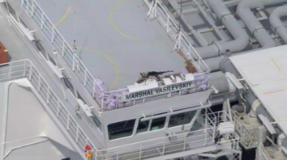  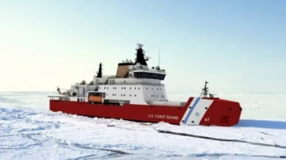 | - On June 30, 2026 Germany and the Netherlands established a joint NATO command center in Estonia to strengthen the alliance's eastern flank and deter Russia. The new headquarters will coordinate NATO forces in Estonia and Latvia, improving regional defense and reinforcing Europe's growing role in NATO security. --->INFO SECTOR: MILITARY / PARAMILITARY ACTIONS – TERRORISM  - On July 2, 2026 Estonian authorities said that Russia has equipped the LNG vessel Marshal Vasilevskiy with heavy machine guns, raising security concerns in the Baltic Sea. Analysts said that this action may be intended to put pressure on NATO, as inspections and sanctions enforcement against Russian shipping by NATO Member States increase. --->INFO SECTOR: TRANSPORTATION ROUTES AND RESOURCES  - On July 3, 2026 the U.S. Coast Guard has finalized contracts for six Arctic Security Cutters worth about $3.3 billion, to be built in the U.S. and Finland. The ships will be delivered between 2028 and 2031 as part of a joint U.S.–Finland–Canada icebreaker program aiming at strengthening Arctic security and transit operations. --->INFO SECTOR: TRANSPORTATION ROUTES AND RESOURCES

SOUTH AMERICA – NW AFRICA / LIBYA
{ Chart 2 }      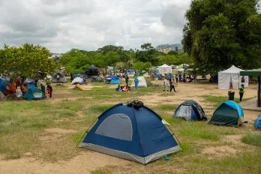 | - On July 1, 2026 twelve people have been sentenced to death by hanging in Nigeria after being convicted of terrorism, kidnapping, murder, and other terrorist-related crimes. The cases involved attacks linked to groups such as Boko Haram and ISWAP, as well as offences including arms trafficking and terrorism support. --->INFO SECTOR: HIJACKING / KIDNAPPING & SMALL ARMS FIRING  - On July 1, 2026 Mercosur leaders called for stronger regional cooperation against transnational organized crime, proposing a shared security framework for intelligence and border control. The summit also discussed trade disputes and economic imbalances among member states. --->INFO SECTOR: PIRACY / ORGANIZED CRIME / BOARDING CONDITIONS  - On July 3, 2026 a week after two powerful earthquakes struck Venezuela, at least 2,645 people have been confirmed dead and 38,500 remain missing, with rescue teams continuing search efforts. Thousands have been displaced, while survivors have criticized the government's disaster response and construction standards amid the growing humanitarian crisis. --->INFO SECTOR: NAVIGATIONAL SAFETY / ENVIRONMENTAL
BLACK SEA – EAST MEDITERRANEAN
{ Chart 3 }  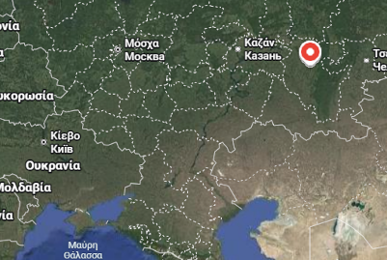  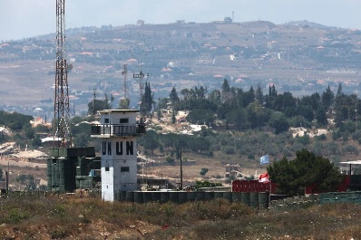    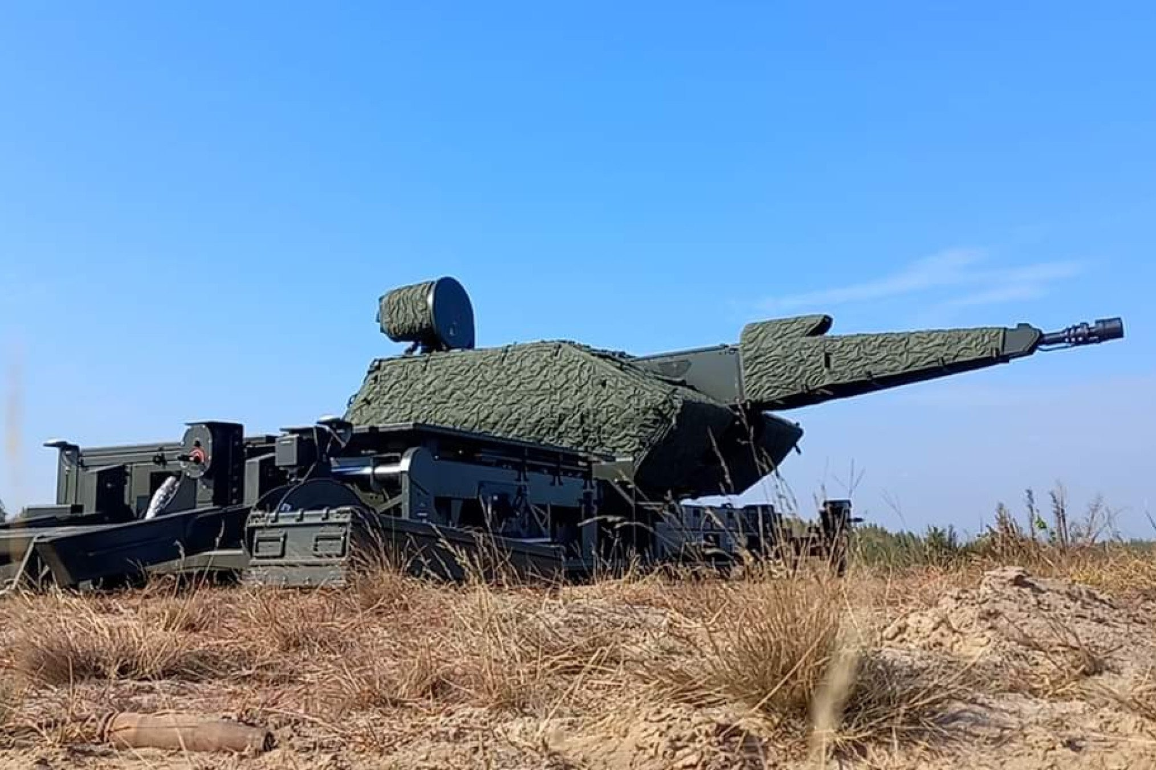  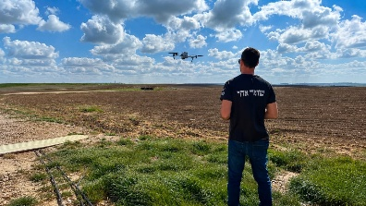 | - On June 29, 2026 US-backed Israel–Lebanon framework to end the conflict by disarming non-state armed groups, restoring Lebanese state control, enabling phased Israeli withdrawal, and supporting reconstruction through coordinated international mediation. --->INFO SECTOR: POLITICAL  - On July 1, 2026 Ukraine said it struck Russia’s Ufa oil refinery and a missile components plant, while Russia reported stopping hundreds of Ukrainian drones. The attacks target Russia’s energy and military infrastructure as Kyiv seeks to pressure Moscow to end the war. Russia has also reduced its missile and drone attacks on Ukraine compared with the previous month. --->INFO SECTOR: MILITARY / PARAMILITARY ACTIONS - TERRORISM  - On July 2, 2026 Israel continued military operations in southern Lebanon, carrying out drone strikes, artillery fire, and demolition activities in several border villages. The attacks came despite a recent framework agreement, as tensions remain high and Israeli forces maintain positions in parts of southern Lebanon. --->INFO SECTOR: MILITARY / PARAMILITARY ACTIONS - TERRORISM  - On July 3, 2026 Black Sea Petroleum announced it will stop refining Russian crude oil for August and September 2026, switching to non-Russian supplies. The move follows scrutiny over alleged links to Russian oil shipments through Georgia's Kulevi terminal and aims to improve access to international export markets, while addressing sanctions-related concerns. --->INFO SECTOR: ECONOMIC AND RESOURCES PERFORMANCE / RESTRAINS  - On July 5, 2026 Ukraine released footage showing a German-made Skynex air defense system intercepting a Russian Kh-101 cruise missile. Ukrainian officials said the system has also destroyed 34 Shahed drones and two Kh-101 missiles, highlighting its effectiveness against aerial threats. --->INFO SECTOR: MILITARY / PARAMILITARY ACTIONS - TERRORISM  - On July 5, 2026 a new report estimates that organized crime and extortion cost Israel's economy NIS 23 billion annually, adding about NIS 8,000 a year to the average household's expenses. The study says rising costs are driven by extortion, theft, and agricultural crime, which increase housing, food, insurance, and tax costs. --->INFO SECTOR: PIRACY / ORGANIZED CRIME / BOARDING CONDITIONS

RED SEA – GULF OF ADEN
{ Chart 4 }  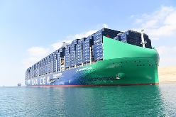   | - On July 1, 2026 Container ship traffic through the Suez Canal reached its highest weekly level since January, with 35 transits in the week ending June 28, according to Drewry. The consultancy said a potential US-Iran agreement could encourage more vessels to return to the Suez route. --->INFO SECTOR: TRANSPORTATION ROUTES AND RESOURCES  - On July 2, 2026 an Yemeni tribal leader has threatened escalation against the Houthi movement if his detained brother is not released within 24 hours, amid rising tensions over arrests in central Yemen. The dispute highlights growing friction between local tribes and Houthi authorities, raising fears of possible armed confrontation. --->INFO SECTOR: POLITICAL

PERSIAN GULF – ARABIC SEA
{ Chart 5 }      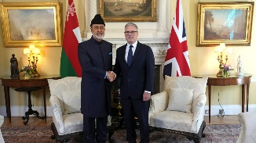    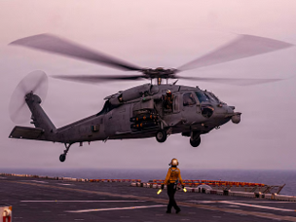 | - On July 1, 2026 the US and Iran have begun indirect talks in Doha, Qatar, with mediation from Qatar and Pakistan, aiming to end the Middle East war. Discussions focus on a ceasefire, reopening the Strait of Hormuz, and a possible deal on Iran’s nuclear program. Iran denied plans for direct talks with the US. --->INFO SECTOR: POLITICAL  - On July 2, 2026 Iran’s military command warned that oil tankers passing through the Strait of Hormuz must follow routes approved by Tehran or face a “forceful response,” escalating tensions in a key global shipping lane. The warning comes amid ongoing US-Iran talks and heightened regional security concerns. --->INFO SECTOR: TRANSPORTATION ROUTES AND RESOURCES  - On July 4, 2026 France and the UK have agreed with Oman to improve security and ensure safe shipping through the Strait of Hormuz, including readiness to deploy a multinational mission. The initiative aims to protect freedom of navigation in the strategically important waterway amid broader regional tensions. --->INFO SECTOR: TRANSPORTATION ROUTES AND RESOURCES  - On July 5, 2026 Maritime trade between Iran and Qatar has resumed after a five-month suspension, restoring shipping between Iran's Dayyer Port and Qatar's Al Ruwais Port. The reopening follows the recent Iran-US ceasefire agreement and marks another step toward restoring Gulf trade after months of conflict-related disruption. --->INFO SECTOR: TRANSPORTATION ROUTES AND RESOURCES  - On July 6, 2026 the US Navy has ended its search for a sailor missing after an MH-60S Sea Hawk helicopter made an emergency water landing in the Arabian Sea on July 1. Three crew members were rescued, while the missing sailor was not found. The Navy said there is no indication of hostile action. --->INFO SECTOR: MILITARY / PARAMILITARY ACTIONS - TERRORISM

EAST ASIA – MALACCA STRAIT / TAIWAN
{ Chart 6 }  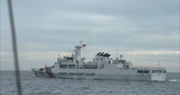  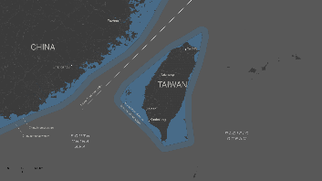 | - On July 4, 2026 China has condemned maritime boundary talks between Japan and the Philippines east of Taiwan, claiming they are illegal because Beijing was not involved. The dispute has increased tensions, with China expanding coast guard operations in the area, prompting criticism from Western countries over threats to freedom of navigation. --->INFO SECTOR: POLITICAL  - On July 4, 2026 China has deployed another coast guard fleet into waters east of Taiwan, prompting Taiwan to condemn the move as illegal and deploy its own vessels to monitor the patrol. The incident highlights rising cross-strait tensions as Beijing expands coast guard operations to reinforce its territorial claims. --->INFO SECTOR: MILITARY / PARAMILITARY ACTIONS - TERRORISM

SEA GUARDIAN overall conclusions
- POLITICAL: Increased policy fluctuations and unexpected changes in regional alliances; expect rapid changes in access, sanctions, and security guarantees.
- ECONOMIC AND RESOURCES PERFORMANCE / RESTRAINTS: Evolution of energy and resources logistic chains, including some uncertainty regarding sources and compliance of shipments involving Russia and newly discovered minerals.
- MILITARY / PARAMILITARY ACTIVITIES – TERRORISM: Continuing presence of localized conflicts and military build-up in strategic theatres, with increased risks of collateral disruption of harbors, bunkering centers and logistic lines.
- PIRACY / ORGANIZED CRIME / BOARDING CONDITIONS: Increased risk of piracy in Bab al Mandeb, Gulf of Aden, Horn of Africa and the Western Indian Ocean; expect high probability of boarding attempts and hostage situations on merchant vessels and fishing boats.
- HIJACKING / KIDNAPPING & SMALL ARMS FIRING: Continuing threat for crews, subcontractors and ground transport in selected parts of Africa and the Middle East.
- TRANSPORTATION LINES AND RESOURCES: Politically determined Hormuz, Suez, Baltic and Arctic transit lines; routing and insurance problems for energy and container transportation.
- GNSS / ECDIS / AIS ELECTRONIC INTERFERENCE GNSS/ECDIS/AIS – CYBER INCIDENTS: Incidents involving cybersecurity in financial and government agencies can swiftly translate to trade financing and trust, making cyber-resilience an important component of port and maritime security management.
- NAVIGATION SAFETY / ENVIRONMENT: A large disaster can suddenly impact port infrastructure, hinterland logistics and crews' well-being, necessitating contingency route planning and emergency response plans.

SEA GUARDIAN major observations
- POLITICAL: States are using diplomacy and pressure over chokepoints and borders, so access and rules can change rapidly.
- MILITARY THREATS: Ongoing conflicts and deployments near key regions raise the risk of indirect impact on commercial operations.
- INTERNATIONAL TRADE: Energy and cargo flows are being rerouted by sanctions, crises and costs, adding volatility to supply chains.
- MARITIME ROUTES: Hormuz, Suez and Western Indian Ocean transits face tighter control, piracy and cautious recovery, requiring flexible routing.
- ORGANIZED CRIME: Piracy and cross-border crime are re-emerging where security and governance are weak, increasing exposure for vessels.
- CYBER VULNERABILITY: Attacks on critical institutions show that cyber incidents can quickly disrupt trust, finance and logistics linked to shipping.

